Pastors and Churches,
Don’t Ignore
2018 Tax Changes

Deduction for Unreimbursed Employee Business Expenses Eliminated

It is important for pastors and churches to understand how they are impacted by the new tax law signed by President Trump on Dec. 22, 2017, and now in effect for the 2018 tax year.
One big change is the elimination of the deduction for unreimbursed employee business expenses. That change makes it more important than ever for pastors and their churches to set up an accountable ministry expense reimbursement account, as detailed in this brochure.
The new tax law, with its much higher Standard Deduction, has the potential to be beneficial for many pastors and churches -- but only if they understand the new rules and make sure that all of a pastor’s ministry expenses are covered under an accountable reimbursement plan.

Standard Deduction Almost Doubled

The new tax law almost doubles the Standard Deduction, which goes up to $12,000 for single filers and $24,000 for married couples filing jointly. As a trade off, the personal exemption has been eliminated and so have most itemized deductions.
In the past, some pastors who itemize deductions on Schedule A have listed unreimbursed ministry expenses, such as mileage, dues, meals and entertainment, books and subscriptions, etc. However, under the new rules, deductions for unreimbursed business expenses for employees, which include most pastors, have been eliminated.
The reasoning behind the changes was to make the tax system simpler and more convenient. Although itemizing deductions can be tedious, taxpayers have done so when the result is better than taking the Standard Deduction. Now that the Standard Deduction is higher and unreimbursed business expenses cannot be deducted on Schedule A, many more taxpayers, including most pastors, will take the Standard Deduction.

Accountable Reimbursement Account

For many years Pastoral Care Inc. has encouraged pastors to take advantage of an accountable expense reimbursement plan. Now setting up such a plan with your church is more important than ever.
If a pastor is paying for ministry expenses out of one’s own pocket, it is better to set up a reimbursement account, even if doing so requires reducing your income from the church. Reimbursement for expenses, if done properly, is not considered income and is not taxable.

Important notes about this brochure

• This information is about how the new tax law affects your 2018 taxes, which you will file next year (2019). The new law did not change your 2017 taxes, for which you will probably file a return this spring.
• This information is about pastors and other ministers who are considered employees of a church. Other rules apply to other kinds of ministers, such as self-employed ministers (e.g., traveling evangelists) and employees of religious organizations other than churches. The IRS has clear guidelines for who is considered an employee, and the IRS considers the typical pastor of the typical church to be an employee of the church.
• Pastoral Care Inc. is not a tax consultant. Our purpose is to inform you of how the new tax law may affect the tax liability of pastors. Consult a qualified tax professional to determine how the new tax law directly affects you.

Step-By-Step Guide to Set Up an
Accountable Ministry Expense
Reimbursement Account

First, Establish the Policy and Account

No. 1. The pastor should review out-of-pocket expenses from previous tax years for such things as mileage, dues, meals and entertainment, books, subscriptions, and other ministry-related expenses. Use this information as a basis for estimating ministry expenses for the new year.
No. 2. The church board (or other governing entity) should create a ministry expense account to reimburse the pastor’s expenses. Pastoral Care Inc. encourages churches to be generous in covering a pastor’s ministry expenses. However, if it is necessary to reduce the pastor’s salary to cover the ministry expense account, that is a better solution than for the pastor to continue to pay expenses out-of-pocket.
No. 3. Make sure that creation of the ministry expense account is formally approved by the church board and recorded in the minutes. Make sure the church specifies who will administer the account to satisfy the accountability requirement.
No. 4. The church will probably want to specify a cap (maximum) of ministry expenses to be reimbursed. If a cap is set, it can be for whatever time period it chooses, e.g., monthly, annually (calendar year) or employment year (if the pastor’s contract falls in the middle of the year). Determining the right cap for a pastor’s expense account is a tricky business. See the example on the back panel to consider several scenarios.
No. 5. If desired, the policy may allow the church to pay an advance for reimbursable expenses. For example, the church may give the pastor a weekly or monthly expense advance. However, as discussed next, the expenses must be substantiated and any unspent or unsubstantiated portion of the advance must be returned.
Account Belongs to the Church, Not the Pastor
No. 6. The expense account must be set up as an expense of the church, part of the church’s annual budget, not as part of the pastor’s salary. An expense account is no longer considered the pastor’s money; it is the church’s money, budgeted to pay legitimate ministry expenses incurred by the pastor on behalf of the church.
No. 7. Therefore, the pastor’s salary cannot be manipulated in accordance with fluctuations in expenses. When a church sets up an accountable reimbursement expense account for the first time, it may be forced to reduce the pastor’s salary in order to afford the expense account (although the IRS has hinted that even that step is questionable).
However, the pastor’s salary may not be repeatedly adjusted in response to fluctuating expenses. For example:
• The church may not reduce the pastor’s salary to increase the expense account to cover an unexpected expense.
• The church may not direct unused expense money to the pastor by increasing the pastor’s salary.
No. 8. Neither the church nor the pastor should report the expense account as income to the pastor. It is an expense of the church, not employee compensation.
No. 9. It is a good practice for the church to review and possibly adjust the pastor’s compensation and the expense account annually. It is a good practice for both the pastor’s compensation and the expense account policy to be approved and recorded in the minutes annually. However, these should be treated as separate budget items, documented separately.
Next, Report Your Expenses
No. 10. Expenses to be reimbursed must be for a legitimate ministry purpose (in IRS language, the expense must have a “business connection”). Acceptable ministry purposes include mileage (but not commuting to and from your church), dues, meals and entertainment (related to church business), continuing education, conventions, conferences, seminars, office supplies, books, CDs, subscriptions, computers and other business equipment, and cell phone use (to the extent the cell phone is used for ministry purposes).
No. 11. The tax rules require that the pastor “substantiate” expenses being reimbursed and that the pastor be held accountable for those expenses. Substantiation typically takes the form of a periodic expense report. The IRS requires that expenses above $75 be documented by a receipt; many churches require receipts for expenses above $25.
No. 12. The expense report may be submitted weekly, twice monthly or monthly. The IRS requires that a reimbursed expense be substantiated within 60 days from the time the expense is incurred. We have a printable version on our website: www.pastoralcare.org
No. 13. Use it or lose it: If the pastor receives an advance for expenses, any unspent or unsubstantiated expenses must be returned to the church within 120 days of receiving the advance.

Several Scenarios Considered

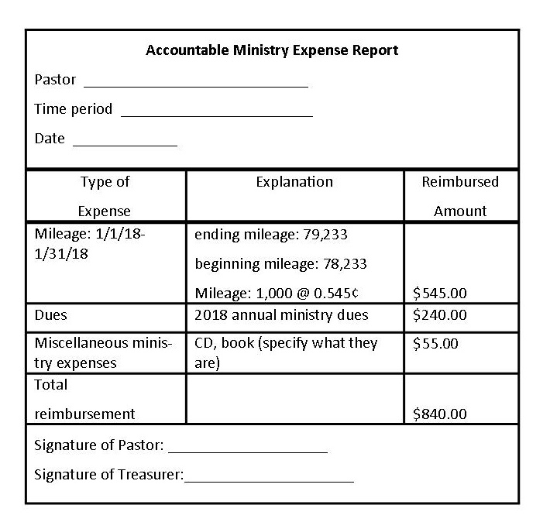

The pastor above has submitted $840 of ministry expenses for January 2018. How the church responds to this expense report depends on the policy it has established:
1. If the pastor has properly substantiated the expenses and the treasurer (or other administrator) has approved the expenses, and if the church has no cap on reimbursable expenses, the pastor should receive a reimbursement check for $840.
2. If the church has a cap of $10,000 per year on reimbursable expenses, the pastor will receive a reimbursement check for $840, with $9,160 left in the account for the remainder of the year.
3. If the church has a cap of $500/month on reimbursable expenses, the pastor will receive a reimbursement church for $500, even though the expenses exceed that amount.
4. If the church has a cap of $500/month and the pastor received a $500 advance for expenses at the beginning of the month, the pastor has already been reimbursed.
5. If the church has a cap of $500/month and the pastor turned in expenses for $320 for the month rather than $840, the pastor should receive a check for $320 and the remaining $180 will not be disbursed.
6. If the church has a cap of $500/month, and if the pastor received a $500 advance, and if the pastor turned in expenses of $320 per month rather than $840), the pastor must return $180 to the church.

Pastoral Care Inc.
Supporting and strengthening pastors
Copyright © 2018 Pastoral Care Inc. All rights reserved.

